Diamond Class daily learning tasks 22.06.20

Please remember that there are now online daily English lessons that you can follow as well as continuing with the books we sent home if you wish. We have purchased Power Maths workbooks for your child should you have finished the maths we sent home at the start of school closure. If you would like the new workbook, please contact school to arrange a time to pick it up from the staff car park. It will be left in a bag on the double gates so you can simply pick it up with out any contact.
Please also remember that you can still complete Doodle Maths, English, Times tables and Spellings daily.

Miss Williamson has planned all the History, Geography and Art for this week and Miss Swinson continues to plan Forest School activities for Diamond class on Fridays. Miss Williamson has finished her placement with us now and will be starting full time teaching in her new school in September. I would like to thank her for all her hard work with Diamond Class and wish her every success in her new teaching job.
We start a new English book this week – Flotsam. Miss Swinson has planned these English lessons and they, and all the related resources, are available as separate attachments. I’m sure you will enjoy all these lessons!
Monday | - History:  This week we are going to investigate Great Yarmouth’s Herring industry.  - Look at the document ‘Herring industry.’ Using this information, answer the following questions.  - When did the Herring Industry begin?  - Why was it important for the town of Great Yarmouth?  - What colour are herrings?  - When is the fishing season?  - Where would you go to catch the herring?  C1: With help, I can answer 3 questions relating to the Great Yarmouth Herring Industry.  C2: I can answer 4 questions relating to the Great Yarmouth Herring industry.  C3: I can answer all the questions relating to the Great Yarmouth Herring industry.  *C: I can independently write about the Great Yarmouth Herring industry.
Tuesday | Geography  - Look at the clips on coastal erosion from BBC Bitesize. https://www.bbc.co.uk/bitesize/clips/zqsgkqt  - Complete the document, ‘Process of coastal erosion.’  C1: With help, I can complete the worksheet, ‘Process of coastal erosion.’  C2: I can complete the worksheet, ‘Process of coastal erosion.’  C3: I can independently explain the process of coastal erosion.  *C: I can independently explain the process of coastal erosion and draw a diagram that explains the process.
Wednesday | Computing  Please see attached file ‘Scratch computing project’ for seven weeks worth of computing lesson plans. You should be on Week 4.
Thursday | Art  - This week we are going to finish our own ‘The Great Wave of Kanagawa’ painting/drawing.  - You should have already drawn and painted the wave. If not, look back at the attached document, ‘Drawing the wave.’  - On a separate piece of paper, canvas or cardboard we are going to create the background of our own ‘The Great wave of Kanagawa.’  - Using watercolour, acrylic paints, pencils or crayons, blend streaks of red, orange and yellow to create the background. If you need help with blending, there is a great technique you can use: apply water and blend with a paint brush using different strokes. Use a dry paint brush or tissue paper to blend, or use your fingers.  - Once the background is dry, return to the wave. Cut around the wave and little mountain carefully.  - Stick the wave onto the background. If you need some help look at the attached document, ‘example of background and wave.’  - Remember this is your artwork so make it unique.  - Refer back to Hokusai’s original artwork to help you.  - *C: write your name in Japanese to the left or right hand side of the artwork.
Friday | Forest school activities  Week 3 – clay parrots.  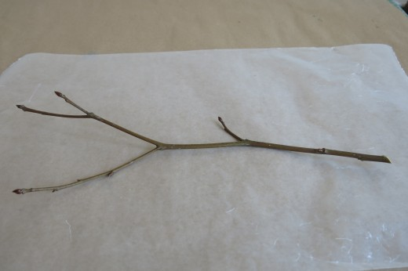  This week we are going to make a clay parrot to go with our pirate ship.  The first step is to find a stick for the parrot to sit on.  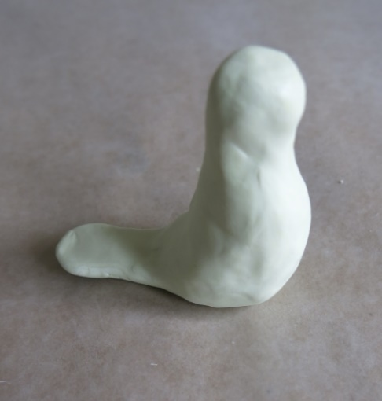  Using two thirds of your clay, make a body shape like this.  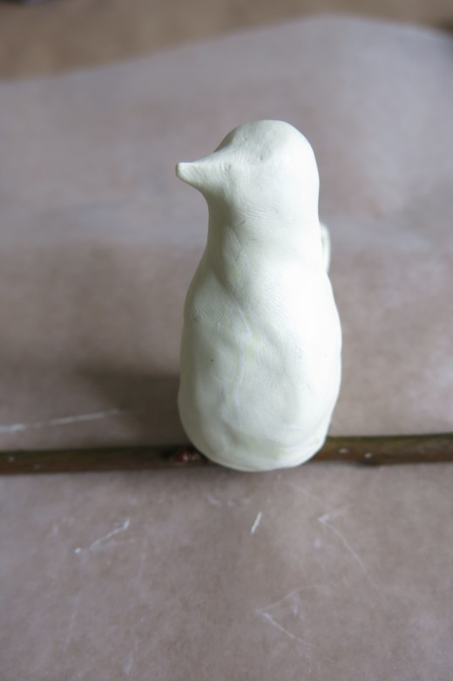  Next, either pinch out a beak shape or add extra clay for the beak. If you add extra clay, make sure you smooth it in or it will fall off when the clay dries. Sit the body on the stick ensuring it is bedded in well.  This is not a parrot beak. Take a look at the final picture to make sure you get the shape right.  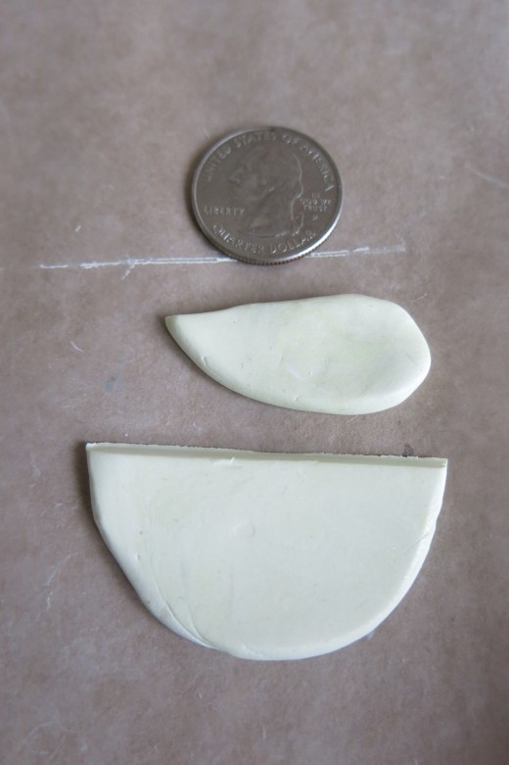  Make some wings in whatever shape you want. Make sure they are big enough to cover the sides of the body. The bird in these pictures only has a small tail feather and parrots have long tail feathers. Can you make a longer tail shape? It could be one large shape or several smaller feather shapes.  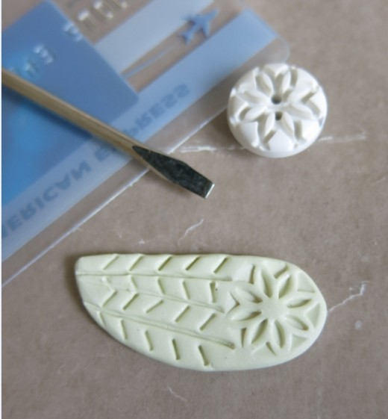  Using a pencil, stick or anything else you can find outside, decorate the tail and wings to look like feathers. This picture gives you some ideas but you can do whatever you like. See what patterns pinecones etc will make in the clay.  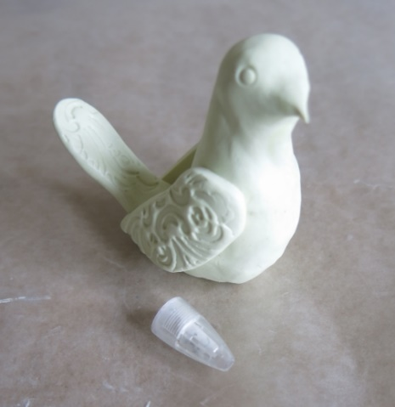  Finally add your wings to the sides and the tail to the back. To help them stick better, draw cross hatches on the back of the piece being attached and the site it is being attached to. Adding some water to both sites will also help them to stick better.  Don’t forget to add some eyes to your finished piece. Remember this picture is not a parrot so yours should have a nice long tail and a different shaped beak!  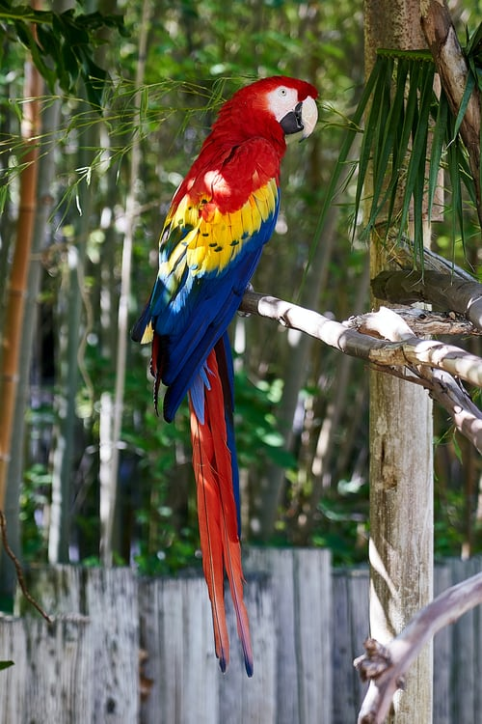  Once your clay is dry you could paint it brightly like this.  If you are at home and don’t have any clay, then your challenge is slightly different. Using leaves, sticks, stones and anything else you can find outside, can you make a parrot?  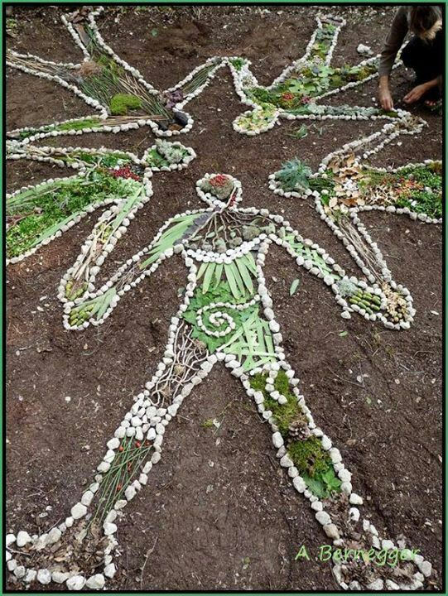  Using the style of artist Andy Goldsworthy, someone created these human figures.  Can you create a parrot from natural materials?  As ever, if you can take a picture to share your work then that would be great.

