Week beginning  22.06.20 | Emerald Class daily learning tasks  Maths: year 1 and 2s should have a ‘Busy Ants’ maths book to work on at home. Please call school to arrange collection of your ‘Power Maths’ book. Do a page every day. You could then develop the skills you have been working on using www.topmarksmaths.co.uk, try to go on hit the button each day to improve your times tables or number bonds. Don’t forget you can go on ‘Doodle’ too.  School is open every day, so if you would like more reading books just call the office to arrange a time to collect them.  PE: Try to do something active each day. Joe Wicks is hosting a daily live PE lesson from his living room at 9:00-9:30 each morning, which you can join in with. There are many other similar activities you could try, from yoga to home workouts, from the safety of your home. You can find this on Youtube.
Monday | Science  See teeth experiment activity
Tuesday | Forest school  See textures activity
Wednesday | Coasts  See the activities about coasts
Thursday | Music  See ‘The Big Ship Sails on the Ally, Ally, Oh’ activity
Friday | RE  See the ‘Jonah and the Whale’ forgiveness activity.
Week beginning  22.06.20 |  | Emerald Class English activities  C1 is intended for reception children, C2 for year 1 and C3 for year 2.
Monday  The Lighthouse Keeper’s Picnic by Ronda and David Armitage  Instructions  C1: Look at the pictures. What can you see. Describe each of the foods, thinking about the colours and sizes of them.  C2: Which plate do you think looks yummiest? Copy it and describe what you can see and why it looks tasty.  C3: Look at the pictures and describe them in as much detail as you can. Imagine you are making a menu to go with the food you can see. How would you describe each plate? |  | Read the story of the Lighthouse Keeper’s Picnic.  You can watch it here https://www.youtube.com/watch?v=dmbae5zsN5o  Mrs Grinling makes a special picnic in the story. Describe what she has made using the pictures to help.  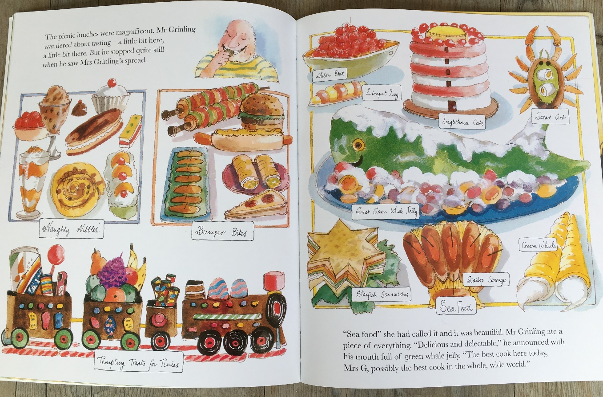
Tuesday |  | Design your own special picnic meal  What would you pack up in a special picnic meal? Can you think of seaside or lighthouse themed food for Mr Grinling?  C1: Discuss what you would make for your special picnic. You could have a go at making something with an adult or perhaps if you have playdoh you could make some playdoh cakes for Mr Grinling.  C2: Decide what you would make for your special picnic meal. Draw and label the different foods.  C3: Decide what you would make for your special picnic meal. Draw and describe it in as much detail as you can.
Wednesday |  | Mr Grinling needs to get fit – design a fitness plan for him. Think about some activities Mr Grinling could do without any equipment. Star jumps, running on the spot, pushups etc.  C1: Show an adult your workout. Can you think of a good way to record it? A video, photos, pictures.  C2: Show an adult your workout. Can you think of a good way to record it? A video, photos, pictures. Remember to think about how many of each exercise Mr Grinling will need to do. Can you explain how to do the different actions? E.g. jump with your legs apart and then jump with them together.  C3: Show an adult your workout. Can you think of a good way to record it? A video, photos, pictures. Remember to think about how many of each exercise Mr Grinling will need to do. Can you explain how to do the different actions? E.g. jump with your legs apart and then jump with them together. Explain what each exercise will do to help Mr Grinling. E.g. this one will help strengthen your arms.
Thursday |  | Big Write: year 1 and 2 children should do this independently, without adult support.  Design a healthy menu for Mr Grinling.  C1: draw a healthy meal for Mr Grinling – he needs a drink, a main course and a dessert. Perhaps you could help to make your own lunch and talk with your grown up about what parts make it healthy.  C2: draw a healthy meal for Mr Grinling – he needs a drink, a main course and a dessert.  Label the different foods.  C3: draw a healthy meal for Mr Grinling – he needs a drink, a main course and a dessert. Describe each part of the meal, explaining why it is healthy for Mr Grinling.
Friday  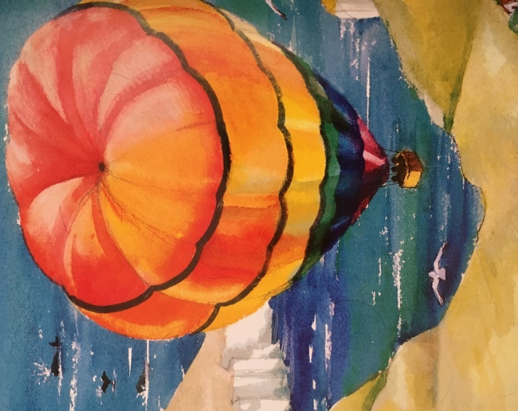 |  | Write the next part of the story as Mr Grinling floats off in the hot air balloon. What could he see? Where did he go? Did he enjoy the trip? What about Mrs Grinling?  C1: Describe what you think Mr Grinling will see on his hot air balloon trip. Draw a picture of the view and label the things he can see.  C2: Describe what you think Mr Grinling will see on his hot air balloon trip. Draw a picture of the view and write sentences to describe the view.  C3: Describe what you think Mr Grinling will see on his hot air balloon trip. Write descriptive sentences using coordinating conjunctions to describe the view.  e.g. It was chilly up in the sky although there wasn’t a cloud in sight.

